Des collections aux musées.
Collectionneurs et passeurs culturels au temps de Feliks Jasieński (1861-1929)
From Collections to Museums:
Collectors and Cultural Mediators in the Time of Feliks Jasieński (1861-1929)

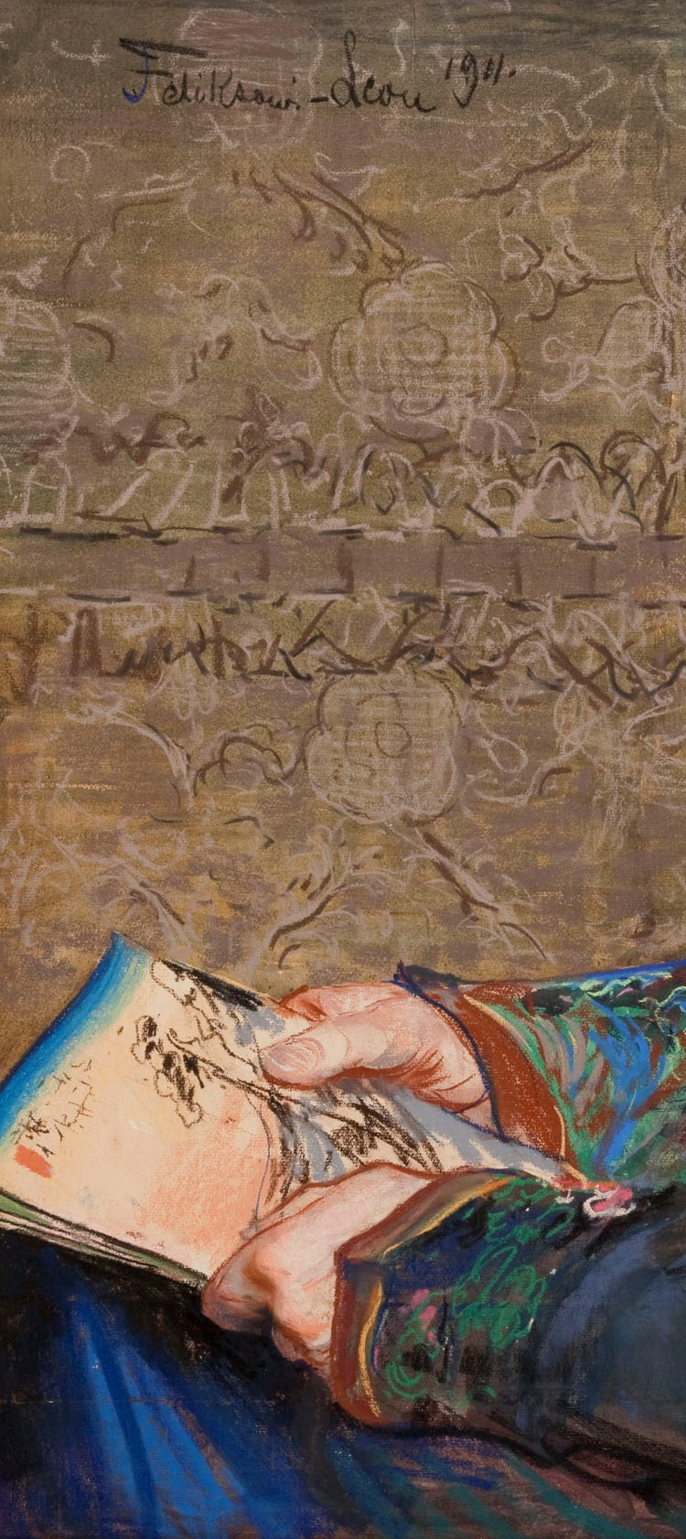
International symposium – Paris
Polish Academy of Sciences, Scientific Centre in Paris
Auditorium, Institut national d’histoire de l’art - INHA
November 18-19, 2021

Organizers
Polish Academy of Sciences, Scientific Centre in Paris
Centre de civilisation polonaise Sorbonne-Université, Paris
Polish Institute of World Art Studies, Warsaw
Saprat (Savoirs et pratiques du Moyen Âge à l’époque contemporaine), Ecole pratique des hautes études – Paris Sciences Lettres
Institut Polonais, Paris

Partners
National Museum in Krakow
The Chapter of the Prize “Feliks Jasieński. Collecting – research and popularization”, Warsaw-Krakow

Project Coordinators
Ewa Bobrowska, Rossella Froissart, Agnieszka Kluczewska-Wójcik

Scientific Committee
Rossella Froissart (Saprat, EPHE - PSL); Agnieszka Kluczewska-Wójcik (Polish Institute of World Art Studies, Warsaw); Ewa Bobrowska (independent scholar & Terra Foundation for American Art, Paris); Magdalena Sajdak (Polish Academy of Sciences, Scientific Centre in Paris); Iwona Pugacewicz (Centre de civilisation polonaise Sorbonne-Université); Anna Biłos (Institut Polonais, Paris); Jerzy Malinowski (Polish Institute of World Art Studies, Warsaw); Adam Knapik (Polish Academy of Sciences, Scientific Centre in Paris); Natalia Pstrąg (Polish Academy of Sciences, Scientific Centre in Paris); Anna Ciesielska-Ribard (Centre de civilisation polonaise Sorbonne-Université).
Leon Wyczòłkowski, Portrait of Feliks Jasieński, 1911
pastel on papier, 84,7 x 98,1 cm (detail), National Museum in Krakow.

The keynote address, « Feliks Jasieński et les collectionneurs de son temps », will be delivered by Professor Krzysztof Pomian on November 19.

This international and interdisciplinary symposium is organized on the occasion of the centenary of the donation of the Feliks Jasieński collection to the National Museum of Krakow.
The Jasieński collection is comprised of more than fifteen thousand works of art assembled in the last decade of the nineteenth century and the first two decades of the twentieth century. It includes Polish and French modernist paintings, sculptures and prints, a collection of Japanese (woodblock prints, paintings, objets d’art) and Middle Eastern (Islamic carpets and fabrics) art, decorative arts, and Polish folk art. It reflects Jasieński's passion for both Western avant-garde art and Eastern art, and deserves the same level of scholarly attention as other prestigious collections such as those of Jacques Doucet or Charles Lang Freer. In his taste and collecting practice, Jasieński was influenced by the circle of curators and amateurs, who at the time worked for museums, such as Raymond Kœchlin, Jules Maciet, Justus Brinckmann, and Ferenc Hopp.
Jasieński's approach as a collector and "artistic activist" is notable for its extraordinary modernity, especially in terms of the diversity of media: he was interested in painting and sculpture, but he also collected works of folk art, decorative art objects and non-European arts. These creations, which transcend traditional aesthetic canons and geographical boundaries, offer an insight into his development as an art amateur and, later, art connoisseur. His approach is also remarkable in view of the efforts he undertook to make his collection accessible to the public by organizing exhibitions, conferences, and other educational activities, which led to its eventual donation to the Museum of Krakow.

The symposium will offer a new perspective on the activity of a whole generation of collectors/cultural mediators, of whom Jasieński is an emblematic representative. Presentations will explore the extent of institutional and social networks through which ideas about art and collecting circulated at the turn of the nineteenth century and, going beyond the sole case of the Polish collector to touch on one of the essential features of the functioning of the "Art Worlds" (H. S. Becker) at that time. Interventions by scholars from different disciplinary fields and geographical areas will allow to go beyond the limits of national narratives, in the wake of the horizontal history of art proposed by Piotr Piotrowski. This approach, which implies a transnational perspective, intends to highlight the plurality of regional histories, and will offer a useful complement to the current concept of European cultural geography, which is still largely limited to the Western area.

Presentations will focus in particular on:
- the changes in collecting practices at the turn of the 19th and 20th centuries, and more specifically the broadening and the diversification of its traditional fields;
- the role of collectors in developing museum collections with works and objects “outside the canon”;
- the role and impact of the art market on the evolution of private collections;
- the expanded access of a diverse public to art and culture;
- the relationship between different artistic centers and their influence on the cultural life in Europe.

Languages of the conference: French and English.

A peer-reviewed publication will ensure the dissemination of research results.

November 18, 2021
Polish Academy of Sciences, Scientific Centre in Paris
74 rue Lauriston, 75116 Paris
9:15 – Welcoming remarks: Magdalena Sajdak, Polish Academy of Sciences, Scientific Centre in Paris, Jerzy Malinowski, Polish Institute of World Art Studies, Warsaw

The Institutional Networks
Chair: Agnieszka Kluczewska-Wójcik, Polish Institute of World Art Studies, Warsaw
9:30 – Arnaud Bertinet, Université Paris 1 Panthéon-Sorbonne
Krzysztof Pomian, Le musée. Une histoire mondiale
10:00 – Julie Verlaine, Université Paris 1 Panthéon-Sorbonne
Les sociétés d’amis des musées autour de 1900, de Paris à Cracovie en passant par Berlin. La naissance transnationale d’un mécénat collectif
10:30 – Break
11:00 – Pedro Lorente, Universidad de Saragoza
Collections et demeures muséalisées à l'origine des « quartiers artistiques »
11:30 – Lucie Chopard, Saprat, EPHE – PSL
Du domestique au muséal : l'installation de la collection Grandidier à l'entresol de la Grande Galerie du musée du Louvre (1895-1915)
12:00 – Discussion

Musealisations of Private Collections
Chair: Ewa Bobrowska, independent scholar & Terra Foundation for American Art, Paris
14:30 – Hanna Rudyk, Bohdan and Varvara Khanenko Museum, Kyiv
Bohdan and Varvara Khanenko and Their ‘Encyclopedic’ Art Collection. Unfolding a Vision of Public Museum in Ukraine on the Turn of 19th - 20th centuries
15:00 – Pauline Prevost-Marcilhacy, Université de Lille
De la collection aux musées : l'exemple de Léon Gauchez, promoteur de l'art moderne
15:30 – Break
16:00 – Vita Susak, independent scholar, Basel
From Private Collections to the National Institutions, Lviv’ Examples.
16:30 – Milena Woźniak-Koch, Zentrum für Historische Forschung Berlin der Polnischen Akademie der Wissenschaften
Between the Private and Public. Warsaw Art Collecting and Its Impact on Museums (1880-1939)
17:00 – Discussion
November 19, 2021
Auditorium, Institut national d’histoire de l’art
2 rue Vivienne, 75002 Paris

Feliks Jasieński and His Donation to the National Museum in Krakow
Chair: Rossella Froissart, Saprat, EPHE – PSL
9:30 – Krzysztof Pomian, musée de l’Europe, Brussels
Feliks Jasieński et les collectionneurs de son temps
10:30 – Break
10:45 – Agnieszka Kluczewska-Wójcik, Polish Institute of World Art Studies, Warsaw
Feliks Jasieński collectionneur et donateur du Musée national de Cracovie
11:15 – Tomasz de Rosset, Uniwersytet Mikołaja Kopernika, Toruń
Léguer la collection – les musées polonais à l'époque de Jasieński
11:45 – Discussion

The New Practicies of Collecting
Chair: Arnaud Bertinet, Université Paris 1 Panthéon-Sorbonne
14:00 – Léa Saint-Raymond, École normale supérieure, Paris
Des collectionneurs plus omnivores ? Systèmes de préférences et pratiques du collectionnisme au tournant des XIXe et XXe siècles
14:30 – Kamila Kłudkiewicz, Uniwersytet Adama Mickiewicza, Poznań
Izabella Czartoryska-Działyńska and Other Women Collectors. The Question of Female Art Collection at the Turn of the 19th and 20th Centuries
15:00 – Bénédicte Gady, musée des Arts décoratifs, Paris
Quels arts décoratifs européens pour quelle réforme américaine ? La famille Hewitt en ses meubles et en son musée
15:30 – Break

Arts from Elsewhere
Chair: Jerzy Malinowski, Polish Institute of World Art Studies, Warsaw
16:00 – Tomáš Winter, Ústav Dĕjin Umĕní, Akademie Vĕd České Republiky, Prague
From Ethnographic Object to Art: Collecting and Exhibiting African Art and Czech and Moravian Folk Art. In Prague around 1890

16:30 – Györgyi Fajcsák, Hopp Ferenc Azsiai Müvészeti Múzeum, Budapest
Collecting Oriental Art in Hungary during the Dualist Era (1867-1918). Founding of the Ferenc Hopp Museum
17:00 – Markéta Hanova, Národní galerie, Prague
Discovering Japanese Art: Collectors at the Heart of Europe
17:30 – Discussion

