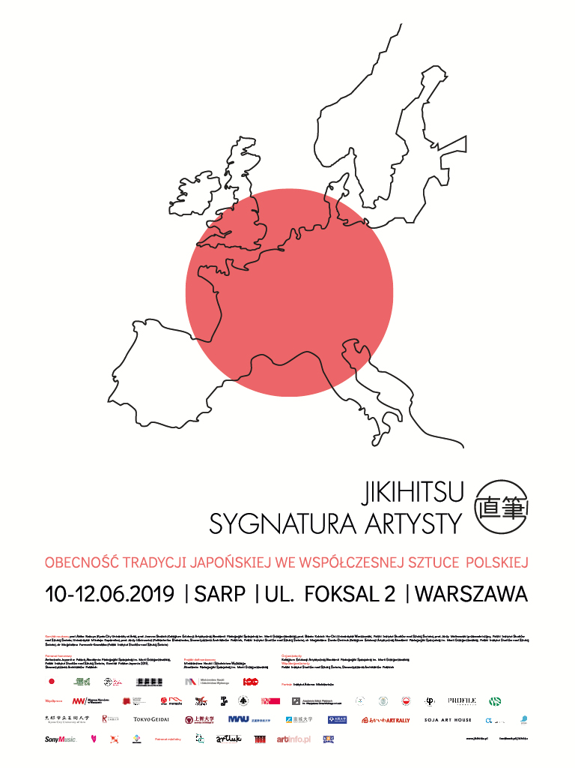
“Jikihitsu. The Signature of the Artist. The Presence of Japanese Tradition in Contemporary Polish Art” – conference and accompanying events

PROGRAMME

International Conference:
Jikihitsu. The Signature of the Artist. The Presence of Japanese Tradition in Contemporary Polish Art
10-12 June 2019, The Association of Polish Architects, Foksal 2, Warsaw

Monday, 10 June 2019
9.30-10.00
registration of participants, coffee
10.00
official opening of the conference
10.20-10.40
prof. Jerzy Malinowski
(Polish Institute of World Art Studies, Nicolaus Copernicus University, Toruń)
“Polish and Japanese Approach. Activity of the Polish Institute of World Art Studies”
10.40-11.00
prof. Akiko Kasuya
(The Kyoto City University of Arts)
“Celebration – Polish-Japan Contemporary Art Presentation”
11.00-11.20
Paweł Pachciarek
(Osaka University; Adam Mickiewicz Institute, Poznań; Polish Institute of World Art Studies)
“Japaneseness in the Activities of Cotemporary Polish Artists on the Example of a Polish-Japanese Contemporary Art Exhibition Celebration”
11.20-11.40
prof. Michio Hayashi
(Faculty of Liberal Arts, Sophia University Tokyo, Japan)
“The Euro-Japanese Relationship through the Concept of Ornament/Decorative Art”
11.40-12.00
Katarzyna Nowak
(Manggha Museum, Cracow)
“Living National Treasures of Japan – Exceptional Presence at Manggha Museum”
12.00-12.20
discussion, coffee
12.20-12.40
prof. Michael Schneider
(The Tokyo University of the Arts [Geidai])
“Cultural Interrelations between Europe and Japan Observed in Printed Art – an Artist’s View”
12.40-13.00
Katarzyna Anna Maleszko
(National Museum in Warsaw, Polish Institute of World Art Studies)
“What is the East to the West? On Our Inspiring Meetings”
13.00-13.20
prof. Shigemi Inaga
(International Research Centre for Japanese Studies, Kyoto)
“Ushushi and Usturoi, Metempsychosis and Transition”
13.20-13.40
Łukasz Kossowski, Ph.D.
(Museum of Literature, Warsaw; Polish Institute of World Art Studies)
“Point of View. Japanese Signature. Polish Signature”
13.40-14.00
Magdalena Janota-Bzowska, Ph.D.
(Collegium of Art Education, The Maria Grzegorzewska University, Warsaw)
“Sign of the Artist, the Artistic Sign – the Autonomy of the Artist’s Signature“
14.00-14.20
discussion
14.20-15.20
lunch
15.20-15.40
prof. Yuko Nakama
(Ritsumeikan University, Kyoto)
“New Digital Art and Japanese Aesthetics”
15.40-16.00
Zbigniew Wałaszewski, Ph.D.
(Collegium of Art Education, The Maria Grzegorzewska University, Warsaw)
“Fascinating Strangeness. Japanese Culture in the Eyes of Western Filmmakers”
16.00-16.20
Radosław Predygier
(Polish Art and Science Mission in Japan, Okayama; Polish Institute of World Art Studies)
“Polish Trace in Okayama. Polish Art and Science Mission in Japan”
16.20-16.40
Tomohiro Higashikage
(Nomart Gallery, Osaka)
“Life and Death – The Quiet Talking with the Existence”
16.40-17.00
prof. Jerzy Uścinowicz
(Bialystok University of Technology, Białystok; Polish Institute of World Art Studies)
“New Church of Saint Nicholas of Japan at Kamienna Górka in Minsk. The Close Tradition of the Far East”
17.00-17.20
discussion
18.00
dinner

Tuesday, 11.06.2019

9.00-9.20
Milada Ślizińska
(Academy of Fine Arts, Warsaw)
“Magdalena Abakanowicz and Japan”
9.20-9.40
Masako Takahashi (Miura)
(Wonderful Art Production, Japan)
“From Hospital Art to the Irreplaceable Cooperation with Polish artists: Józef Wilkoń and Lidia Dańko”
9.40-10.00
Anna Dzierżyc-Horniak, Ph.D.
(The John Paul II Catholic University of Lublin; Polish Institute of World Art Studies)
“What Is Needed Is Concentration, Inner Silence and Willingness to Listen. Koji Kamoji in Creative Dialogue with Polish Artists”
10.00-10.20
Marta Kowalewska
(Central Museum of Textiles in Łódź)
“Woven Ties. Naomi and Masakazu Kobayashi”
10.20-10.40
Joanna Sitkowska-Bayle
(International Association of Art Critics, Paris)
“Meetings with Japan – artistic output of Aliska Lahusen and Gabriela Morawetz”
10.40-11.00
discussion, coffee
11.00-11.20
Anita Zdrojewska
(Pompka Foundation, PUBLINK Agency)
“BUTOH – Experiments, Provocations and Inspirations: an Endless Trip in the Footsteps of Kazuo Ohno & Tatsumi Hijikata”
11.20-11.40
Yoko Nakata
(Biwako Biennale, Japan)
“Biwako Biennale – Art Festival in the Historical City”
11.40-12.00
Gabriela Morawetz
“Permeation – Image and Movement/Cooperation with Tarinainanika Duo in Context of Biwako Biennale”
12.00-12.20
Magdalena Durda-Dmitruk, Ph.D.
(Collegium of Art Education, The Maria Grzegorzewska University, Warsaw; Polish Institute of World Art Studies)
“A Fragment of the Whole. The Traces of Japanese Aesthetics in the Works on Silk of Selected Polish Female Artists”
12.20-12.40
Rina Matsudaira
(Sony Music, Kyoto)
"Inspired by the Classics of East Asia ―Searching for a meeting place of narratives and paintings"
12.40-13.00
Magdalena Furmanik-Kowalska, Ph.D.
(Polish Institute of World Art Studies)
“European fairy tales and kawaii aesthetic. Experimental photography by Ewa Doroszenko.”
13.00-13.20 discussion

13.20-14.20 lunch

14.20-14.40
prof. Yasuyuki Saegusa
(Faculty of Art, SOJO University, Kumamoto)
“Volcano · Art · Human - Residency Project in Kumamoto, Japan”
14.40-15.00
prof. Agnieszka Rożnowska
(Fine Arts Academy, Warsaw)
“Mono-No-Aware. Memories from Kyushu”
15.00-15.20
prof. Aleksander Woźniak
(Faculty of Fine Arts, University of Warmia and Mazury in Olsztyn)
“Negative Space and the Issue of Transformation in the Process of Artistic Creation. Based on a Project Looking at Tokyo”
15.20-15.40
Kazuhiro Korenaga
(Akaiwa Art Rally, Soja Artists Residence)
“Art as a Mean to Connect Area and People”
15.40-16.00
Chie Piskorska
(Polish-Japanese Academy of Information Technology)
“New Japonism and the Idea of BUNKASAI Japanese Arts Festival”
16.00-16.20
discussion

18.00
finissage of the exhibition, SARP
with performance of Małgorzata Niespodziewana-Rados
and butoh performance: Anita Zdrojewska, Joanna Sarnecka „Wedding – kekkonshiki. BUTOH at Matsuri”

Wednesday, 12 June 2019

9.00-9.20
prof. Joanna Stasiak
(Collegium of Art Education, The Maria Grzegorzewska University, Warsaw)
“Immersion in Seeing”
9.20-9.40
Przemysław Radwański, Ph.D.
(Collegium of Art Education, The Maria Grzegorzewska University, Warsaw)
“Artist’s Work as Meditation. The Influence of Practising Zen on the Creative Process”
9.40-10.00
prof. Małgorzata Niespodziewana-Rados
(Faculty of Art, Pedagogical University of Cracow)
“Practising Mindfulness – On Japanese Experience in Creative Work”
10.00-10.20
Joanna Zakrzewska, Ph.D.
(Polish-Japanese Academy of Information Technology in Gdańsk)
“The Influence of Japanese Calligraphy and Ink Wash Painting on Contemporary Polish Artists”
10.20-10.40
Zbigniew Urbalewicz
(Faculty of Fine Arts, University of Warmia and Mazury in Olsztyn)
“Creative Journeys to the World of Japanese Calligraphy. The Analysis of the Areas of Influence of Aesthetics and Artistic Experiences”
10.40-11.00
Tomasz Rudomino
(Paris)
“Two Faces of Avant-garde: Gutai and Kosai Hori”
11.00-11.20
discussion, coffee
11.20-11.40
prof. Elżbieta Banecka
(Academy of Fine Arts, Warsaw)
“Uncombed from Kyoto”
11.40-12.00
prof. Ewa Latkowska
(Academy of Fine Arts, Łódź)
“The Art of Paper. Paper in Art”
12.00-12.20
Konrad Juściński, Ph.D.
(Michał Iwaszkiewicz Poznan School of Social Sciences in Poznań)
“Two Roads, One Direction_Y_”
12.20-12.40
Nonki Nishimura
(AT ARTS)
“The Eyes of Truth”
12.40-13.00
Atsushi Hosoi
(Musashino Art University in Tokyo)
“On the Progress, Development and Background of the Work of Contemporary Young Wood Sculptor”
13.00-13.20
Paweł Jasiewicz
(Academy of Fine Arts, Warsaw)
“Every Wood Has Its Own Tone, Every House Has Its Own Song”
13.20-13.40
discussion, wrap-up of the conference

13.30
lunch

Accompanying events
22 May, 14.30: vernissage “Art of Józef Wilkoń in Japan”, exhibition of illustrations and sculpture, The Maria Grzegorzewska University Gallery, Szczęśliwicka 40, 22 May-21 June 2019
2-13 June 2019: main exhibition “Jikihitsu. The Signature of the Artist”
painting, textiles, graphics, drawing, sculpture, installations, Pavilion of the Association of Polish Architects, Foksal 2, Warsaw
2-15 June 2019: Joanna Stasiak, “Cities of Fishes”, painting on silk, Piwnica Artystyczna, ul Dewajtis 3, Warsaw
7-14 June 2019: Krzysztof Wodiczko, show of projects' documentation performed in Japan, Profile Foundation, Franciszkańska 6, Warsaw
9 June 2019, 13.00: vernissage Joanna Stasiak, “Cities of Fishes”, painting on silk, Piwnica Artystyczna, ul Dewajtis 3, Warsaw. Performative concert inspired by Joanna Stasiak’s paintings. Zofia Bartoszewicz – intuitive singing, Igor Buszkowski - bass guitar, Jacek Szczepanek - sounds collage.
9 June 2019, 19.00: vernissage “Jikihitsu. The Signature of the Artist” – photography, new media, installations, film, video art, Stara Galeria, pl. Zamkowy 8, Warsaw, 7-21 June 2019
10-12 June 2019: An international conference: “Jikihitsu. The Signature of the Artist. The Presence of Japanese Tradition in Contemporary Polish Art”, Pavilion of the Association of Polish Architects, Foksal 2, Warsaw
11 June 2019, 18.00: official finissage of the main exhibition “Jikihitsu. The Signature of the Artist” with the performance of Małgorzata Niespodziewana-Rados and butoh performance by Anita Zdrojewska and Joanna Sarnecka “Wedding – kekkonshiki” Pavilion of the Association of Polish Architects, Foksal 2, Warsaw
Participants:
Yui Akiyama, Stanisław Baj, Elżbieta Banecka, Mirosław Bałka, Bogna Becker, Fujioka Keiko & Michiko Sakuma, Toshihiro Hamano, Joanna Hawrot, Tomohiro Higashikage, Atsushi Hosoi, Daisuke Ichiba, Paweł Jasiewicz, Konrad Juściński, Maria Kiesner, Hiroo Kikai, Naomi Kobayashi, Shoukoh Kobayashi, Kazuhiro Korenaga, Aliska Lahusen, Ewa Latkowska, Monika Masłoń, Rina Matsudaira, Gabriela Morawetz, Grzegorz Mroczkowski, Małgorzata Malwina Niespodziewana- Rados, Nonki Nishimura, Stefan Paruch, Małgorzata Paszko, Radosław Predygier, Wiesław Rosocha, Agnieszka Rożnowska, Daniel Rumiancew, Yasuyuki Saegusa, Koichi Sato, Michael Schneider, Jarosław Sierek, Joanna Stasiak, Magdalena Świercz-Wojteczek, Masako Takahashi, Emiko Tokushige, Aleksandra Waliszewska, Mieczysław Wasilewski, Józef Wilkoń, Krzysztof Wodiczko, Jakub Woynarowski, Aleksander Woźniak, Joanna Zakrzewska.
Apart from the conference, the programme of Jikihitsu. The Signature of the Artist. The Presence of Japanese Tradition in Contemporary Polish Art. offers also a cycle of accompanying events (main exhibition and a few individual shows, butoh performance, educational workshop and artistic performance) with the participation of outstanding artists from Poland, Japan and France. The aim of these events is to present the influence of Japanese tradition, culture, philosophy and aesthetic on contemporary Polish art and to showcase the works of Japanese artists and their inspiration with European culture.
The subject of the exhibitions will be the mutual relations of Polish and Japanese art, illustrated with the examples of creative output of renowned contemporary artists from both countries (as well as a few Polish artists working in France, in “symbiosis“ with Japanese culture and art). The exhibitions will have two parts. The first one will show the reception of Japanese art by contemporary Polish artists and the traces of Polish artists in Japan. The second one will present the works of artists whose creative activities are set between their home tradition of art and culture of the Far East and European influences.
The exhibitions are of interdisciplinary and multimedia character (painting, textile, graphics, drawing, sculpture, installation, photography, film, new media etc.). We’ll be able to see the works executed in traditional painting of graphic techniques (e.g. painting on canvas, panel, paper, or silk, woodcuts, posters, manggha), as well as the new media means of expression (i.a. photographs, video art). We will also admire a large representation of spatial installations, artistic textile and monumental sculptures.
The programme will be enriched by individual shows: an exhibition of illustrations and objects entitled Art of “Józef Wilkoń in Japan” (The Maria Grzegorzewska University Gallery in cooperation with ARKA Foundation), a video screening and presentation of various materials documenting Krzysztof Wodiczko’s projects carried out in Japan e. g. „Hiroshima“, "Rozbroji" (Profile Foundation), an exhibition of paintings on silk by Joanna Stasiak (Cities of Fish, Piwnica Artystyczna) as well as art therapy workshops with the participation of Masako Takahashi within the framework of her “Hospital Art” activities. The finissage of the main exhibition at the Association of Polish Architects will be further celebrated by the performance of Małgorzata Niespodziewana-Rados and a butoh performance by Anita Zdrojewska and Joanna Sarnecka.
The showcased works of art will illustrate various topics that the conference raises, i.a. definition of space, notion of active emptiness, minimalism, references to Japanese philosophy, spirituality and aesthetic, as well as to the title signature of the artist – jikihitsu, which means the shaping of the creative individuality in the face of influences of the culture and art of the Far East or the other way round – globalisation and Europeanisation.
The participants of the exhibition and the accompanying events are living artists from Poland and Japan, as well as Polish artists living in France – all representing different generations. These are all professional artists who are well known and renowned, in the vast majority having also academic and teaching attainments (lecturing in Poland, Japan and France). They have a strong and lively contact with art, with Japanese artists, traditional Japanese techniques, arts and crafts (e.g. in connection with the artistic residencies or artistic and academic exchange programmes in which they have taken part etc.).
Opr. dr. Magdalena Durda-Dmitruk

