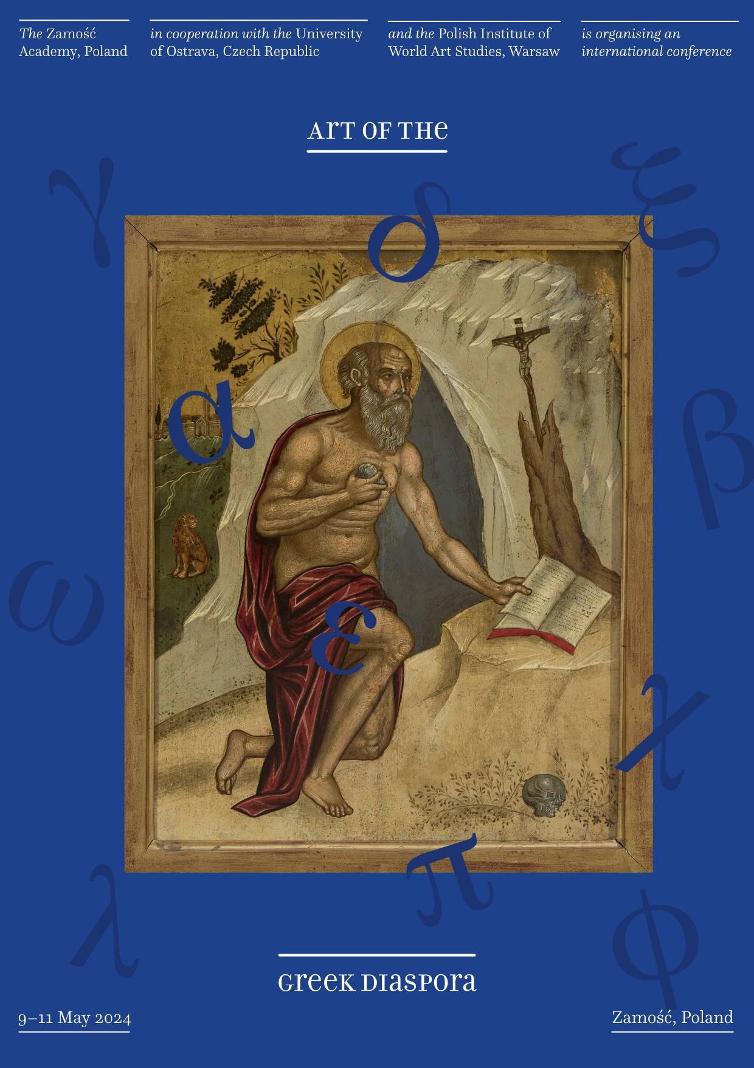

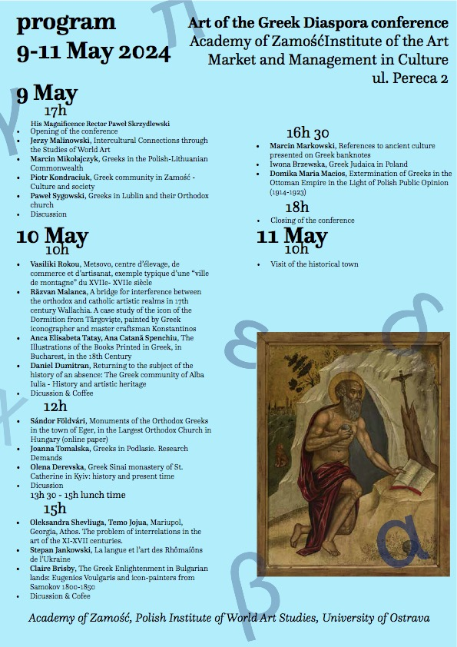

Academy of Zamość, Polish Institute of World Art Studies,
University of Ostrava

Art of the Greek Diaspora conference
Academy of Zamość, ul. Pereca 2

Program 9-11 May 2024

9 May, 17h
Opening of the conference
Jerzy Malinowski, Polish Institute of World Art Studies and research on Diaspora art
Marcin Mikołajczyk, Greeks in the Polish-Lithuanian Commonwealth
Piotr Kondraciuk, Greek community in Zamość
Paweł Sygowski, Greeks in Lublin and their Orthodox church

Discussion

10 May, 10h
Vasiliki Rokou, Metsovo, centre d’élevage, de commerce et d’artisanat, exemple typique d’une “ville de montagne” du XVIIe- XVIIe siècle
Răzvan Malanca, A bridge for interference between the orthodox and catholic artistic realms in 17th century Wallachia. A case study of the icon of the Dormition from Târgoviște, painted by Greek iconographer and master craftsman Konstantinos
Anca Elisabeta Tatay, Ana Catană Spenchiu, The Illustrations of the Books Printed in Greek, in Bucharest, in the 18th Century
Daniel Dumitran, Returning to the subject of the history of an absence: The Greek community of Alba Iulia - History and artistic heritage

Discussion & Coffee

12h
Sándor Földvári, Monuments of the Orthodox Greeks in the town of Eger, in the Largest Orthodox Church in Hungary (online paper)
Joanna Tomalska, Greeks in Podlasie. Research Demands
Olena Derevska, Greek Sinai monastery of St. Catherine in Kyiv: history and present time

Discussion

13h 30 – 15h lunch time

15h
Oleksandra Shevliuga, Temo Jojua, Mariupol, Georgia, Athos. The problem of interrelations in the art of the XI-XVII centuries.
Stepan Jankowski, La langue et l’art des Rhômaíôns de l'Ukraine
Claire Brisby, The Greek Enlightenment in Bulgarian lands: Eugenios Voulgaris and icon-painters from Samokov 1800-1850

Discussion & Cofee

16h 30
Marcin Markowski, References to ancient culture presented on Greek banknotes
Iwona Brzewska, Greek Judaica in Poland
Domika Maria Macios, Extermination of Greeks in the Ottoman Empire in the Light of Polish Public Opinion (1914-1923)

18h Closing of the conference

11 May, 10h – visit of the historical town
